# docker 部署oracle12c

### 创建网络

docker network create --subnet=172.20.0.0/24 oracle-network

### 创建目录

mkdir datas  
chown -R 1001:1001 datas  
或者  
chmod -R 777 datas

### docker-compose.yml

version: '2'  
services:  
 oracle12c:  
 image: truevoly/oracle-12c  
 container_name: oracle12c  
 privileged: true  
 restart:  
 always  
 volumes:  
 - ./datas:/u01/app/oracle  
 - /etc/localtime:/etc/localtime:ro  
 #environment:  
 # DBCA_TOTAL_MEMORY: 16192  
 ports:  
 - "8080:8080"  
 - "1521:1521"  
 networks:  
 oracle-network:  
 ipv4_address: 172.20.0.3  
networks:  
 oracle-network:  
 external: true

### 进入容器

docker exec -it oracle12c bash

root@caf7970f481e:/# sqlplus /nolog

SQL*Plus: Release 12.1.0.2.0 Production on Thu Nov 24 16:29:00 2022

Copyright (c) 1982, 2014, Oracle. All rights reserved.

SQL> connect sys/oracle as sysdba

Connected.

SQL> alter user system identified by "123456"; #修改密码

User altered.

SQL> alter user sys identified by "123456"; #修改密码

User altered.

SQL> grant sysdba to sys;

Grant succeeded.

**此时再创建用户会报错**

SQL> create user oracle12 identified by "123456";

create user oracle12 identified by "123456"

*

ERROR at line 1:

ORA-03135: connection lost contact

Process ID: 575

Session ID: 33 Serial number: 10713

**退出重新登录**

root@caf7970f481e:/# sqlplus /nolog

SQL*Plus: Release 12.1.0.2.0 Production on Thu Nov 24 16:32:37 2022

Copyright (c) 1982, 2014, Oracle. All rights reserved.

SQL> connect sys/123456 as sysdba #之前修改的密码

Connected.

SQL> create user oracle12 identified by "123456"; #创建内部管理员账号

User created.

SQL> grant connect,resource,dba to oracle12; #将dba权限授权给内部管理员账号，或 grant connect,resource to oracle12（给用户授予连接和数据权限）

Grant succeeded.

SQL> ALTER PROFILE DEFAULT LIMIT PASSWORD_LIFE_TIME UNLIMITED; #修改密码规则策略为密码永不过期，oracle密码默认有效期是180天好像，

Profile altered.

**进入容器之后，使用如下命令查看数据库提供监听服务的名字**

root@caf7970f481e:/# lsnrctl status

LSNRCTL for Linux: Version 12.1.0.2.0 - Production on 24-NOV-2022 16:55:05

Copyright (c) 1991, 2014, Oracle. All rights reserved.

Connecting to (ADDRESS=(PROTOCOL=tcp)(HOST=)(PORT=1521))

STATUS of the LISTENER

------------------------

Alias LISTENER

Version TNSLSNR for Linux: Version 12.1.0.2.0 - Production

Start Date 24-NOV-2022 16:22:38

Uptime 0 days 0 hr. 32 min. 27 sec

Trace Level off

Security ON: Local OS Authentication

SNMP OFF

Listener Log File /u01/app/oracle/diag/tnslsnr/caf7970f481e/listener/alert/log.xml

Listening Endpoints Summary...

(DESCRIPTION=(ADDRESS=(PROTOCOL=tcp)(HOST=caf7970f481e)(PORT=1521)))

(DESCRIPTION=(ADDRESS=(PROTOCOL=tcp)(HOST=caf7970f481e)(PORT=8080))(Presentation=HTTP)(Session=RAW))

Services Summary...

Service "xe" has 1 instance(s).

Instance "xe", status READY, has 1 handler(s) for this service...

Service "xeXDB" has 1 instance(s).

Instance "xe", status READY, has 1 handler(s) for this service...

The command completed successfully

root@caf7970f481e:/# lsnrctl status

LSNRCTL for Linux: Version 12.1.0.2.0 - Production on 24-NOV-2022 16:55:12

Copyright (c) 1991, 2014, Oracle. All rights reserved.

Connecting to (ADDRESS=(PROTOCOL=tcp)(HOST=)(PORT=1521))

STATUS of the LISTENER

------------------------

Alias LISTENER

Version TNSLSNR for Linux: Version 12.1.0.2.0 - Production

Start Date 24-NOV-2022 16:22:38

Uptime 0 days 0 hr. 32 min. 34 sec

Trace Level off

Security ON: Local OS Authentication

SNMP OFF

Listener Log File /u01/app/oracle/diag/tnslsnr/caf7970f481e/listener/alert/log.xml

Listening Endpoints Summary...

(DESCRIPTION=(ADDRESS=(PROTOCOL=tcp)(HOST=caf7970f481e)(PORT=1521)))

(DESCRIPTION=(ADDRESS=(PROTOCOL=tcp)(HOST=caf7970f481e)(PORT=8080))(Presentation=HTTP)(Session=RAW))

Services Summary...

Service "xe" has 1 instance(s).

Instance "xe", status READY, has 1 handler(s) for this service...

Service "xeXDB" has 1 instance(s).

Instance "xe", status READY, has 1 handler(s) for this service...

The command completed successfully

### 其他命令

SQL> show con_name;

CON_NAME

------------------------------

xe

SQL> show user;

USER is "SYSTEM"

### 连接数据库

hostname: localhost #主机名  
port: 1521 #端口号  
sid: xe   
service name: xe #服务名  
username: system #用户名  
password: 123456 #密码  
  
#使用如下命令连接sqlplus  
sqlplus system/oracle@//localhost:1521/xe

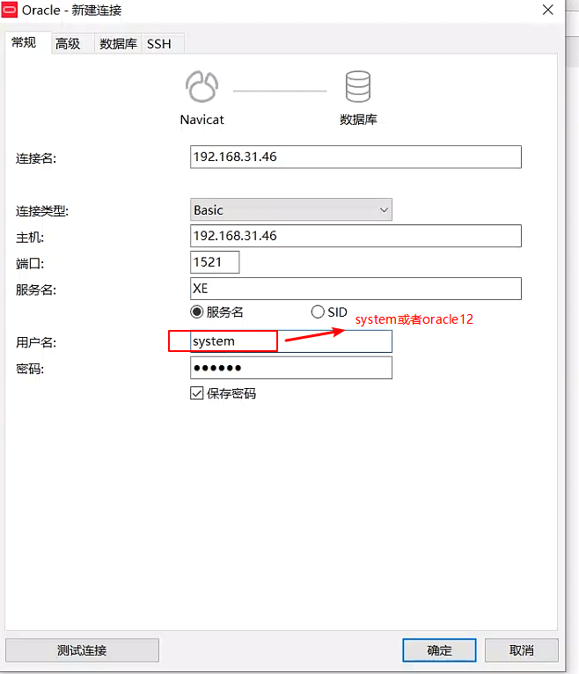

### Oracle Web管理端连接参数:

http://localhost:8080/apex  
 workspace: INTERNAL  
 user: ADMIN  
 password: 0Racle$

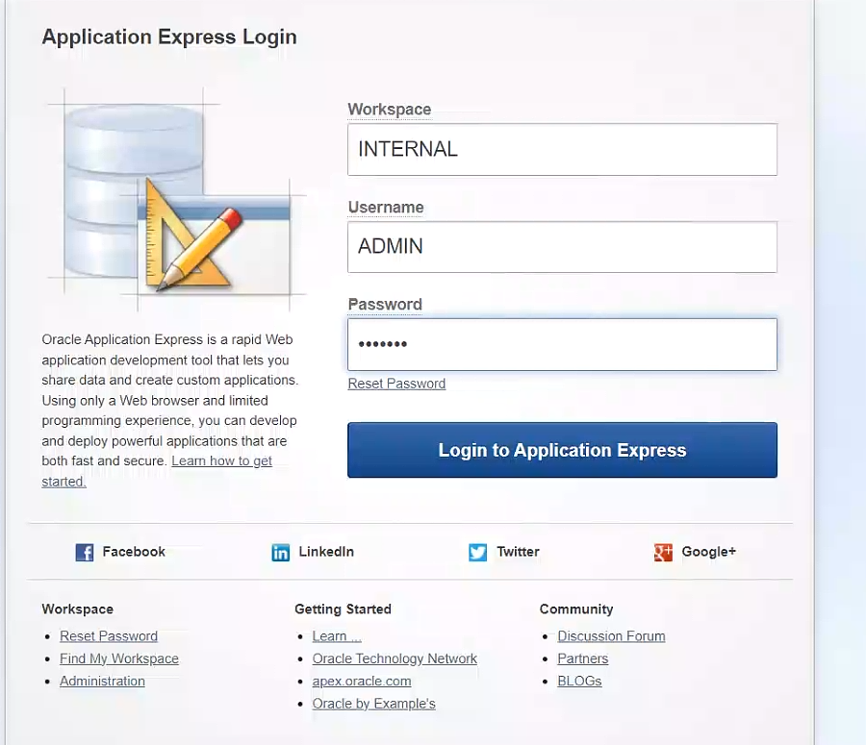

#### 修改密码（须符合密码策略）

Z123.com#(例如密码设置为)

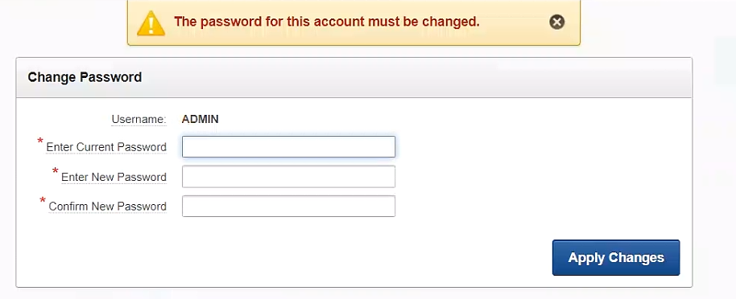

### Oracle企业管理控制台:

http://localhost:8080/em  
 user: sys  
 password: oracle  
 connect as sysdba: true

### 参考文档

[Docker-Compose快速搭建Oracle-12C系统](https://blog.csdn.net/Aria_Miazzy/article/details/93103277)

[Docker 安装Oracle12c](https://blog.csdn.net/wlczh/article/details/123520588)

[Docker安装Oracle 12c](https://blog.csdn.net/lazycheerup/article/details/123815563)